**Website operation environment:**

1. Tomcat v8.5
2. Java jdk-19
3. MySQL 8.0
4. Eclipse 2023-06
5. Other basic jar files(They have been added into the folder:“informal_semester_project\src\main\webapp\WEB-INF\lib”, if you want to operate the codes, only need to setup your eclipse)

**Database design:**

1. robot: Include id, userinfoid, robot_name, username, robot_picture, realTime_map, the primary key is id.
2. showmaze: Include robot_name, username, path, time_interval, treasure_picture, the primary key is username.
3. Userinfo: Include userid, username, password, gender, age, tel, email, the primary key is userid.

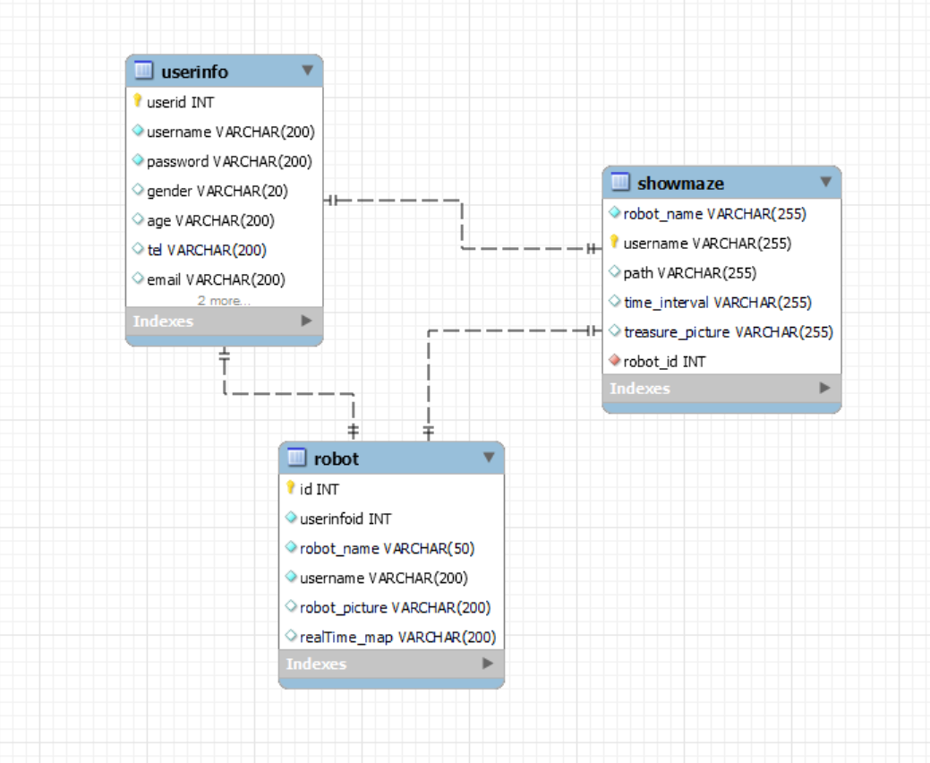

**Some modification before operating the code**

**Suppose** your map address is “***C:\\Desktop\\Maze1.png***”, your folder address which is used to store the image data is “***C:\\Desktop\\upload***”. And you **must construct** such a folder first.

Then there are somewhere which needs to be modified:

1. In the 129/136 lines of the document: “informal_semester_project\src\main\java\webProject\listener\realTime_map.java”,

the address should be “***C:\\Desktop\\Maze1.png***”.

1. In the 90/91 lines of the document: “informal_semester_project\src\main\java\webProject\servlet\AddRobotInfoServlet.java”, the value of “UPLOAD_DIRECTORY” should be “***C:\\Desktop\\upload*”**, and the value of “UPLOAD_DATABASE_DIRECTORY” should be “***\\upload***”.
2. In the 30 line of the document:

“informal_semester_project\src\main\java\webProject\servlet\current_listener.java”,

the address should be “***C:\\Desktop\\upload*”**.

1. In the 163 line of the document:

“eclipse-workspace\Servers\Tomcat v8.5 Server at localhost-config\server.xml”,

the value of “docBase” should be “***C:/Desktop/upload*”**.